U18CO018

Shubham Shekhaliya

Sub: CN

Lab: Assignment 3

Topic : Socket Programming

• Perform Simple Socket Programming

Java Socket programming is used for communication between the applications running on different JRE(Client and Server).

Socket and ServerSocket classes are used for connection-oriented socket programming.

Client in socket programming must know two information:

1. IP Address of Server

2. Port number

Example:

Server2.java

import java.io.\*;

import java.net.\*;

class Server2 {

    public static void main(String args[]) throws Exception {

        ServerSocket ss = new ServerSocket(5000);

        System.out.println("Server started");

        System.out.println("Waiting for a client...");

        Socket s = ss.accept();

        System.out.println("Connection established");

        PrintStream ps = new PrintStream(s.getOutputStream());

        BufferedReader br = new BufferedReader(

                        new InputStreamReader(s.getInputStream()));

        BufferedReader kb = new BufferedReader(

                            new InputStreamReader(System.in));

        while (true) {

            String str, str1;

            while ((str = br.readLine()) != null) {

                System.out.println(str);

                str1 = kb.readLine();

                ps.println(str1);

            }

            ps.close();

            br.close();

            kb.close();

            ss.close();

            s.close();

            System.exit(0);

        }

    }

}

Client2.java

import java.io.\*;

import java.net.\*;

class Client2 {

    public static void main(String args[]) throws Exception {

        Socket s = new Socket("127.0.0.1", 5000);

        System.out.println("Connected");

        DataOutputStream dos = new DataOutputStream(

                                s.getOutputStream());

        BufferedReader br = new BufferedReader(

                new InputStreamReader(s.getInputStream()));

        BufferedReader kb = new BufferedReader(

                            new InputStreamReader(System.in));

        String str, str1;

        while (!(str = kb.readLine()).equals("exit")) {

            dos.writeBytes(str + "\n");

            str1 = br.readLine();

            System.out.println(str1);

        }

        dos.close();

        br.close();

        kb.close();

        s.close();

    }

}

While Compiling Server2.java and at a run time It will show.

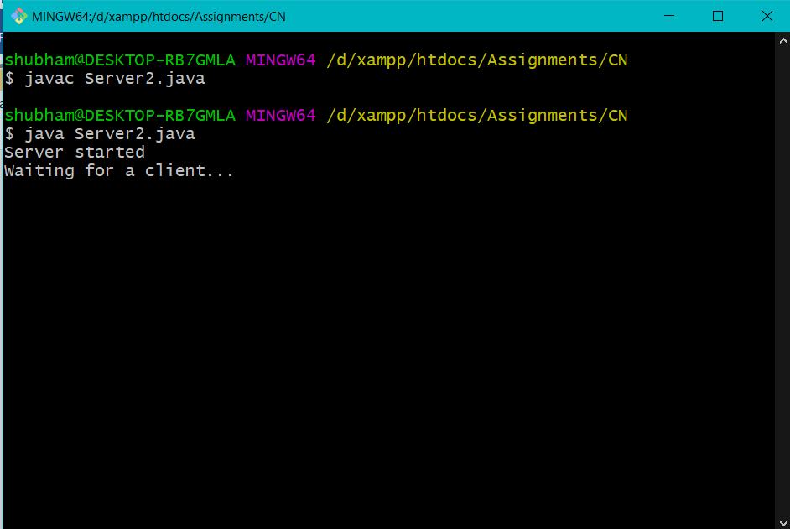

While Compiling Client2.java and at a run time It will show.

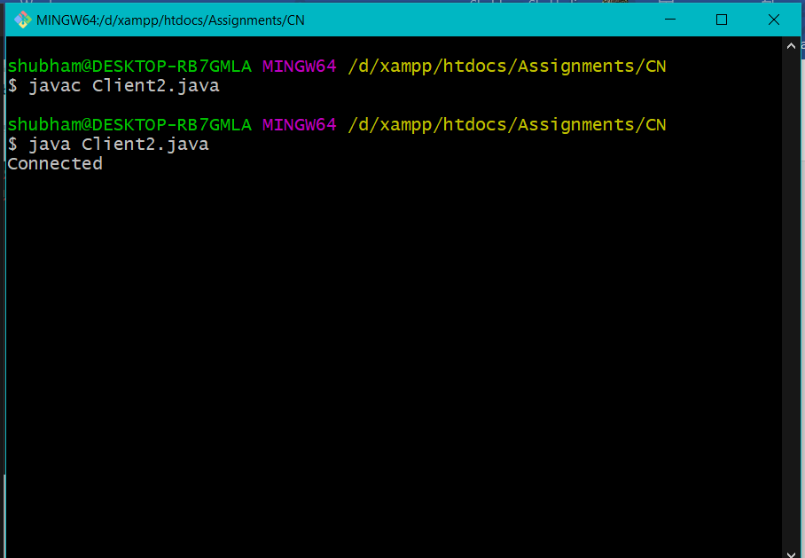

At a Time of Connection Sever Also Show Us Client Connected Message

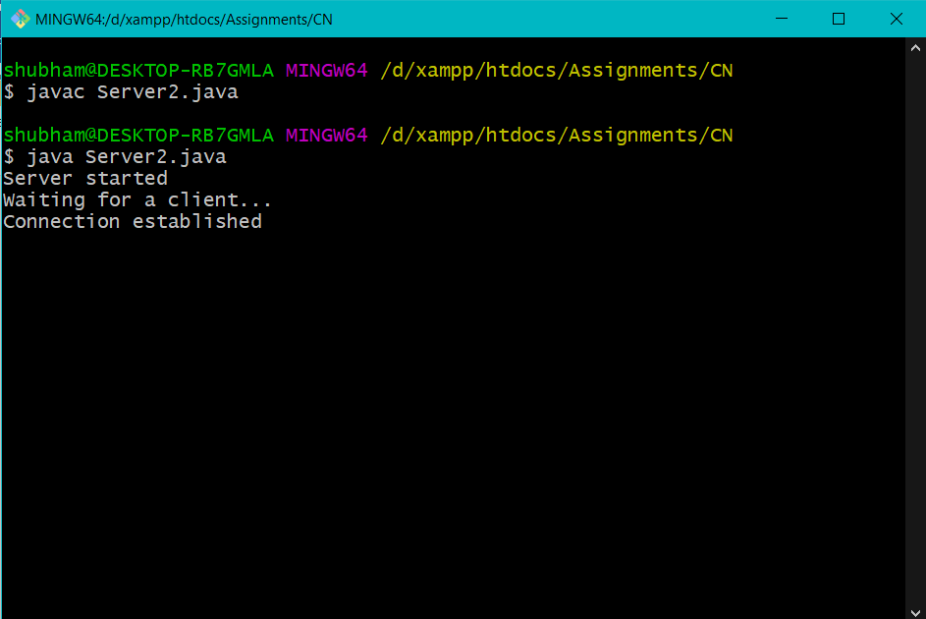

And Whatever message will send through Client then Server will receive and Show the message and also when Server send message Client will receive and show the message.

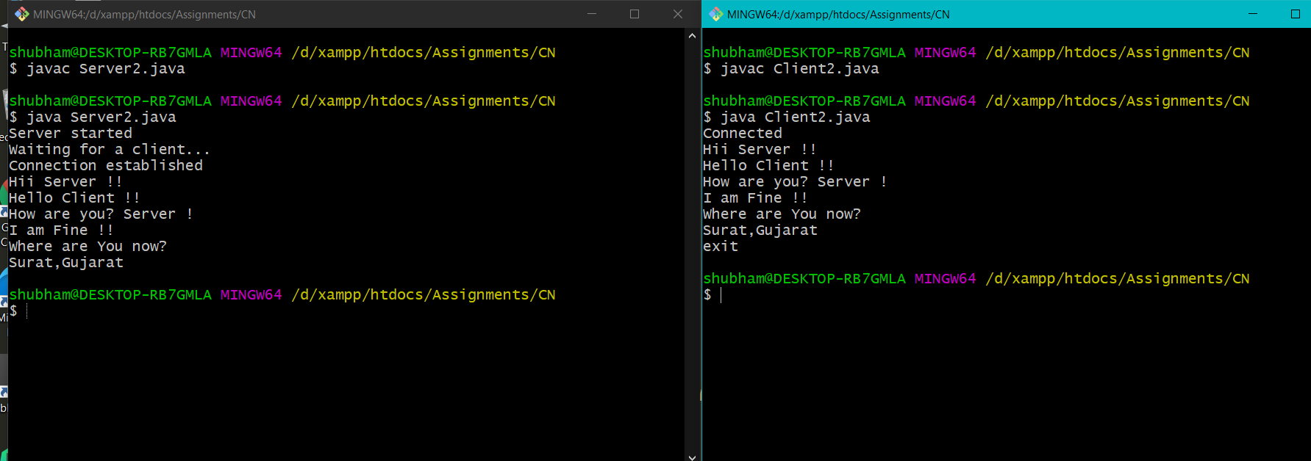

And “exit” Will Closing Connection Message at Server Side and Client Side.